

**Artist Martina Hahn presents   
“Painting ON the Mackinaw”**

**July 20th – Dragonflies! What a happy painting!**

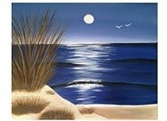

**August 28th – so serene.**

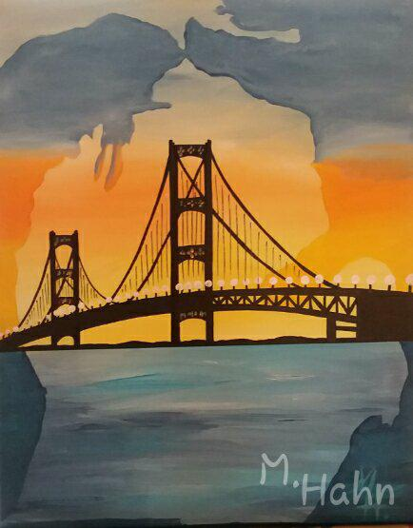

**September 11th – Back by popular demand!**

**To make your reservation, please call the Icebreaker Mackinaw Maritime Museum office at 231-436-9825. Space is limited so please book early.   
Pre-payment will confirm your reservation.**