**Icebreaker Mackinaw Maritime Museum, Inc.**

131 S. Huron Avenue • P.O. Box 39 • Mackinaw City, MI 49701

Telephone 231 436-9825 • Fax 888 435-9524  
www.themackinaw.org

A Nonprofit 501(c)(3) Michigan Corporation

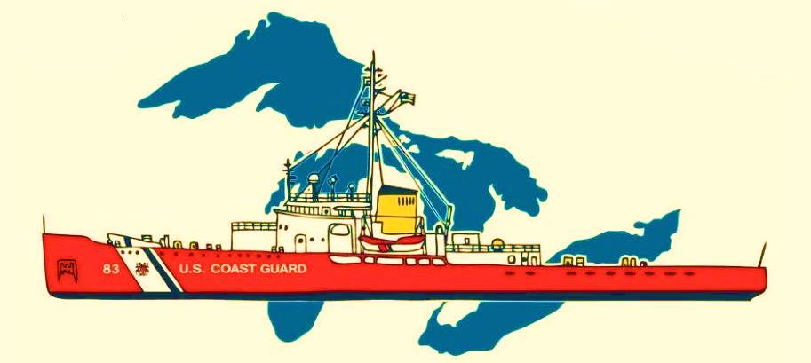

**Scope of Duties:**

**Docents** serve the guests of the Icebreaker Mackinaw Maritime Museum by performing verbal interpretation of the culture, history and facts relating to the ship and its crew.

**Responsibilities:**

1. Enthusiastically greet guests
2. Provide guests with information pertaining to multiple tour areas
3. Be aware of any unsafe conditions and report to management
4. Participate in small maintenance and light cleaning
5. Interact with guests at areas other than assigned tour areas
6. Perform other duties as assigned.

**Requirements:**

1. Ability to read, write and understand/follow written and verbal directions.
2. Ability to effectively communicate factual and approved information to a person or group
3. Present a friendly, outgoing personality.
4. Adjust to varied weather conditions as outdoor work is sometimes necessary
5. Display professional work habits, including:
   1. Professional appearance, wearing a neat and clean uniform, including nametag.
   2. Report to work and be ready to work at the required time.
   3. Display a friendly attitude toward guests and co-workers.

**Physical Requirements:**The ability to traverse many levels of indoor and outdoor stairways.

**Supervision:**  
This position’s immediate supervisor is the Lead Docent

**General Position Information:**This is a temporary seasonal at-will position which serves at the will of the employer.